Uganda

## Respect for rule of law (ROL) data

The data set shows the data on the respect of the rule of law for the country.

## # A tibble: 19 x 5  
## country iso3c date ruleOfLaw ruleOfLawCategory4   
## <chr> <chr> <dbl> <dbl> <chr>   
## 1 Uganda UGA 1996 -0.580 ROL moderately disrespected  
## 2 Uganda UGA 1998 -0.528 ROL moderately disrespected  
## 3 Uganda UGA 2000 -0.786 ROL moderately disrespected  
## 4 Uganda UGA 2002 -0.610 ROL moderately disrespected  
## 5 Uganda UGA 2003 -0.492 ROL moderately disrespected  
## 6 Uganda UGA 2004 -0.630 ROL moderately disrespected  
## 7 Uganda UGA 2005 -0.581 ROL moderately disrespected  
## 8 Uganda UGA 2006 -0.327 ROL moderately disrespected  
## 9 Uganda UGA 2007 -0.360 ROL moderately disrespected  
## 10 Uganda UGA 2008 -0.351 ROL moderately disrespected  
## 11 Uganda UGA 2009 -0.414 ROL moderately disrespected  
## 12 Uganda UGA 2010 -0.398 ROL moderately disrespected  
## 13 Uganda UGA 2011 -0.361 ROL moderately disrespected  
## 14 Uganda UGA 2012 -0.348 ROL moderately disrespected  
## 15 Uganda UGA 2013 -0.341 ROL moderately disrespected  
## 16 Uganda UGA 2014 -0.388 ROL moderately disrespected  
## 17 Uganda UGA 2015 -0.386 ROL moderately disrespected  
## 18 Uganda UGA 2016 -0.247 ROL moderately disrespected  
## 19 Uganda UGA 2017 -0.296 ROL moderately disrespected

## Respect for rule of law (ROL) trend

The plot shows the trend of the respect for the rule of law for the country.

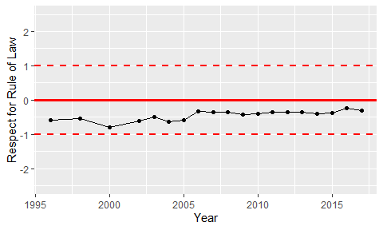

Trend of the Respect for the Rule of Law